EXAM MARKING KEY
0000.doc

CHEMISTRY—ANALYTIC MARKING KEY 3A/3B PAPER
SECTION ONE

Question No | Answer
 | A
 | C
 | C
 | B
 | C
 | D
 | C
 | B
 | B
 | A
 | C
 | C
 | B
 | C
 | A
 | A
 | C
 | D
 | C
 | C
 | B
 | A
 | D
 | D
 | D

SECTION TWO

Question 1 [4 marks]

(a) Circle and name the functional groups.

carboxylic acid
ester
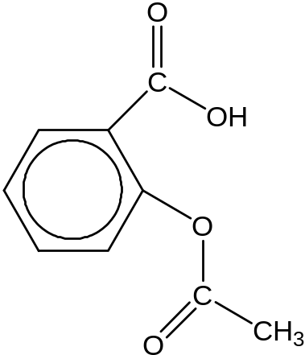

Mark | Description
2 | Both functional groups circled and named
1 | One functional group circled and named
1 | Both functional groups circled and either not named correctly or not named
0 | Question answered incorrectly or not attempted

- Draw structure of reactant 2

C
C
H
H
H
H
O
O

Mark | Description
2 | CH₃COOH (or structure drawn)
1 | CHOOH (incorrect answer but some merit)
0 | Question answered incorrectly or not attempted.

Question 2 [7 marks]
Complete the table by writing the systematic name in the last column or drawing the structure in the first column.
[Each response is worth 1 mark]

Structure | Common name | Systematic name
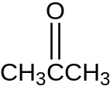 | Acetone | Propanone
 | Acetic acid | Ethanoic acid
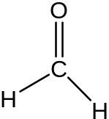 | Formaldehyde | Methanal
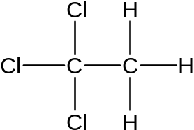 | Liquid paper thinner | 1,1,1-trichloroethane
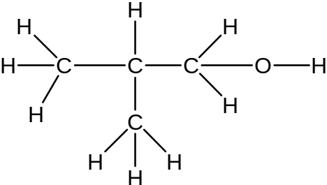 | Isobutyl alcohol | 2-methyl-propan-1-ol
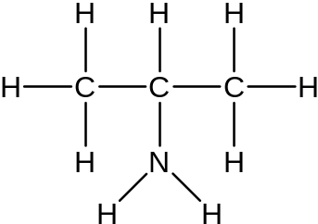 | Isopropyl amine | Propan-2-amine
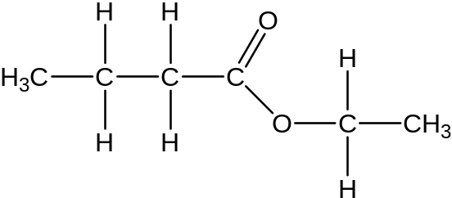 | Butanoic acid ethyl ester (strawberry odour) | Ethyl butanoate

Mark | Description
1 – 7 | One mark for each correct answer
0 | Question answered incorrectly or not attempted.

Question 3 [2 marks]
The characteristic odours of fish are due to the presence of amines. Amines are moderately strong bases. Explain, using an equation, how you could neutralise the fishy odour due to a primary amine.

Mark | Description
2 | 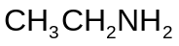 + 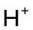 → 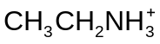  uses correct formulae for reactants and product
1 | uses generalised equation for amine 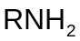
0 | Question answered incorrectly or not at all.

Question 4 [10 marks]
From your knowledge of the solubility rules and reactions, describe what tests you could use to determine the identity of the salt. You must include any relevant observations and equations for each test in your answer. You may wish to use flowcharts, tables etc. to represent your answer. The third unknown can be determined by the process of elimination.

Example of flowchart
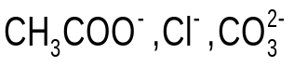
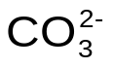
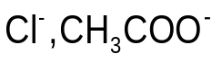
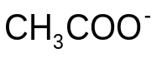
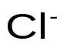
Dissolve in water and add dilute HC
Bubbles of gas
Add
or valid
alternative to give a ppt.
No precipitate
Precipitate
No visible reaction

An alternative solution may involve the testing of the pH of the solutions of the salts.
The solution formed from the C⁻ ions will be neutral, the other two solutions will be basic.
The remaining two solutions could be identified by the addition of dilute hydrochloric acid as in the first step.

Mark | Description
10 | All steps correct and the flow chart represented clearly
1 – 9 | Marks allocated as indicated in the diagram above.
0 | Question not answered correctly or not attempted.

Question 5 [19 marks]

- Complete the table

 | 1 | 2 | 3 | 4
Final reading (mL) | 20.20 | 36.80 | 21.05 | 37.70
Initial reading (mL) | 3.30 | 20.20 | 4.35 | 21.05
Titration volume (mL) | 16.90 | 16.60 | 16.70 | 16.65
[1 mark]

(i) Calculate the average titration volume.

Mark | Description
2 | 16.65 mL
1 | 16.71 mL (have not recognised outlier value of 16.9mL)
0 | Question answered incorrectly or not at all.

(ii) Calculate the number of moles of sodium hydroxide in the average titration volume.

Mark | Description
2 | 1.657 x 10⁻³ mol [1.663 x 10⁻³ mol if wrong value from (i) is used]
1 | Calculation error
0 | Question answered incorrectly or not at all.

n(OH-) = 0.0995(0.01665)
= 1.657 x 10⁻³ mol

(iii) Calculate the concentration of acetic acid in the original vinegar solution. Express your answer in both mol L⁻¹ and g L⁻¹

Mark | Description
5 | 0.414 mol L⁻¹ and 24.9 g L⁻¹
4 | If units missing or incorrect significant figures
OR
1 – 5 | Allocate marks as indicated in the working provided below.
0 | Question answered incorrectly or not at all.

n(CH₃COOH in 20.00 mL) = n(OH⁻)
= 1.657 x 10⁻³ mol (1 mark)
n(CH₃COOH in 100.0 mL) = 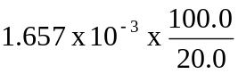
= 8.28 x 10⁻³ mol (1 mark)
= n(CH₃COOH) in 20.0 mL undiluted vinegar. (1 mark)
c(CH₃COOH) = 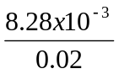
= 0.414 mol L⁻¹ (1 mark)
c(CH₃COOH in g L⁻¹) = 0.414(60.05)
= 24.9 g L⁻¹ (1 mark)

- Describe three potential sources of error in this experiment and how you would minimise them.

Mark | Description
3 | Any three acceptable sources of error and description of minimisation are required.  e.g. inconsistent titre results – rinse conical flask with water OR burette with solution OR pipette with solution  Titre value too high – use appropriate indicator.
2 | Two sources of error with no explanation of minimising  One source of error plus minimising description
1 | One source of error
0 | Question answered incorrectly or not at all.

- Phenolphthalein is an appropriate indicator for this titration as the pH at which the end point occurs is 8.3. How would the calculated concentration of acetic acid compare to the actual value if methyl orange was used (which changes colour at 4.3)? Explain your answer using the terms end point and equivalence point.

Mark | Description
4 | The end point would occur before the equivalence point  A smaller volume of NaOH would be required to reach the end point or average titre would be smaller. This would result in the concentration of vinegar appearing lower than it really is.
3 | A smaller volume of NaOH would be required. No mention of end point occurring before equivalence point.
2 | A smaller volume of NaOH would be required.
1 | Acetic acid concentration would seem lower.
0 | Question answered incorrectly or not at all.

- Describe an example where indicators are used outside the laboratory.

Mark | Description
2 | Pools to monitor pH and chlorine concentration  Soil chemistry – to monitor pH of soils  Or any reasonable answer.  (Answer must include some amount of description.)
1 | Pool or soil  Answer is one word or inadequate description
0 | Question answered incorrectly or not at all.

Question 6 [23 marks]

- Explain in terms of the equations shown why the spray released from the gland of the bombardier beetle is hot.

Mark | Description
2 | Reactions are exothermic, heat energy is produced and so temperature rises
1 | Reaction is exothermic
0 | Question answered incorrectly or not at all.

- Refer to Equation 2 to explain why the spray released from the gland of the bombardier beetle sprays out of the back of the beetle very rapidly.

Mark | Description
2 | Oxygen gas is produced rapidly and pressure builds up (or gas is forced out).
1 | Oxygen is produced OR gas is forced out (or similar).
0 | Question answered incorrectly or not at all.

- A student investigates the effect of the concentration of hydrogen peroxide on the rate of the decomposition reaction (equation 2) in the laboratory. She adds a solid catalyst to hydrogen peroxide solution and measures the rate at which oxygen is given off.

(i) What TWO variables would you expect to control in this experiment?

Mark | Description
2 | States two appropriate variables:  - Mass of catalyst  - Volume of hydrogen peroxide  - Temperature of system.
1 | One appropriate variable given.
0 | Question answered incorrectly or not at all.

(ii) List ONE variable you have to measure and ONE other variable that you could measure to determine the rate of reaction.

Mark | Description
2 | States time and one of two appropriate variables:  - Loss of mass  - Volume of oxygen produced.
1 | States two variables but does not include time.
0 | Question answered incorrectly or not at all.

(iii) Suggest an appropriate method for this experiment. You may include a diagram in your answer.

Mark | Description
5 | Describes a method for measuring the dependant and independent variables and controlling other variables. An appropriate method or labelled diagram for collecting gas or measuring mass loss.
4 | The method is appropriate for measuring the dependant and independent variables but little or no mention of control of other variables. An appropriate method or labelled diagram for collecting gas or measuring mass loss.
3 | The method is appropriate for measuring the dependant and independent variables but other variables are not mentioned or the method for the collection of the gas evolved or the mass loss is not appropriate.
2 | The method identifies measurable variables but the method described is flawed and is not likely to establish a cause and effect relationship.
1 | Some apparatus shown correctly.
0 | Question answered incorrectly or not at all.

- (i) Plot the data on the graph.
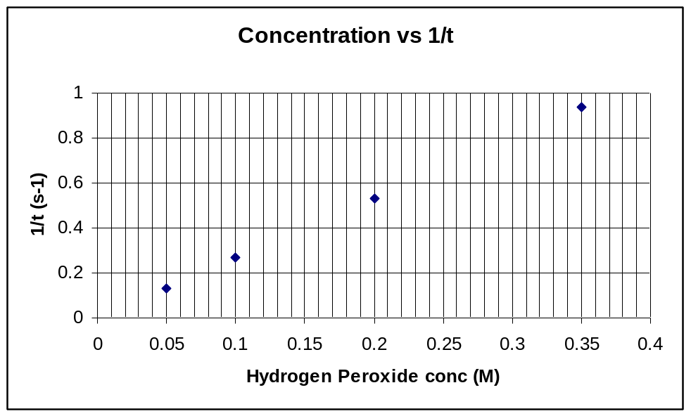
mol L⁻¹

Mark | Description
5 | All five categories given:  - All axes labelled correctly  - Correct units on axes titles  - Points plotted correctly  - Line of best fit  - Graph title.
4 | 4 of the five categories given, including line of best fit.
3 | 3 of the five categories given, but no line of best fit.
2 | 2 of the five categories given.
1 | 1 of the five categories given.
0 | Question answered incorrectly or not at all.

(ii) Based on the data, write a conclusion for this experiment.

Mark | Description
2 | As the concentration of hydrogen peroxide increases the rate of reaction increases.  There is a direct relationship between the concentration of hydrogen peroxide and the rate of reaction.
1 | As the concentration of hydrogen peroxide increases the rate of reaction increases.  OR  There is a direct relationship between the concentration of hydrogen peroxide and the rate of reaction.

(iii) Identify THREE potential sources of error in the experiment.

Mark | Description
3 | Three appropriate potential sources of error stated, such as :  - Beginning timing at the same point each time.  - Gas collection (not allowing gas to escape).  - Air is collected with oxygen .
2 | Two appropriate sources of error stated.
1 | One appropriate source of error stated.
0 | Question answered incorrectly or not at all.

Question 7 [10 marks]

- Calculate the empirical formula.

Mark | Description
6 | C₆H₈O₇
5 | Student calculates correct ratio (1:1.33:1.167) but cannot convert to empirical formula.
3 – 4 | Student calculates part way through calculation.
1 – 2 | Student calculates number of moles of carbon dioxide and/or water.
0 | Question incorrectly answered or not attempted.

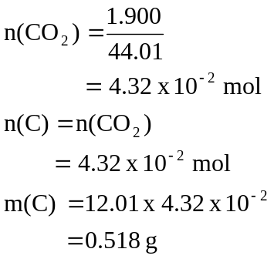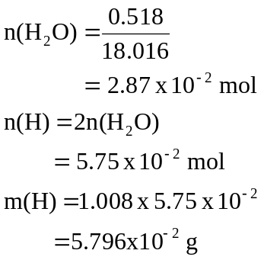

m(O) = 1.383 – 0.518 – 0.05796
= 0.807 g

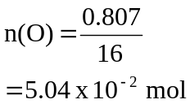

 | C | H | O
n | 4.32 x 10⁻² | 5.75 x 10⁻² | 5.04 x 10⁻²
Ratio | 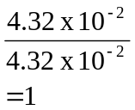 | 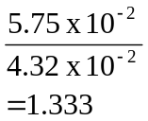 | 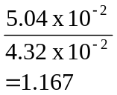
x 6 | 6 | 8 | 7

Empirical formula = C₆H₈O₇

- Determine the molecular formula if the molecular mass of citric acid is 192.1.

Mark | Description
2 | 192
1 | Calculation error.
0 | Question incorrectly answered or not attempted.

Empirical formula mass = (6 x 12.01) + (8 x 1.008) + (7 x 16.0)
= 192
Empirical formula mass = molecular mass

∴ Molecular formula = Empirical formula

= C₆H₈O₇

- Draw a possible structural formula for citric acid given that one mole of citric acid reacts with three moles of potassium hydroxide

Mark | Description
2 | Structure example below.  Structure must contain correct number of carbon, hydrogen and oxygen and have three carboxylic acid groups.
1 | Structure contains correct number of carboxylic acid groups but not the correct number of carbon or hydrogen.
0 | Question incorrectly answered or not attempted.

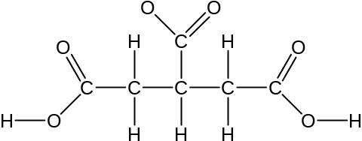
Or any viable structure that shows a triprotic acid with the correct number of carbon, hydrogen and oxygen.

Question 8 [9 marks]

- Excess 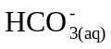 produced as a result of strenuous exercise is removed from the blood by the kidneys.

(i) Describe the immediate change in the pH of the blood.

Mark | Description
1 | The pH of the blood initially decreases.

(ii) Explain the immediate change in the pH.

Mark | Description
2 | The lowering of the hydrogen carbonate ion concentration shifts the equilibrium position of the carbonic acid/hydrogencarbonate reaction to the right, raising the concentration of hydrogen ions and lowers the pH of the blood.
1 | The answer is just given in terms of an increase in hydrogen ion concentration

- Hyperventilation, or rapid breathing, decreases the amount of carbon dioxide in the lungs. As a consequence the concentration of carbon dioxide dissolved in the blood also decreases

(i) Describe the immediate change in the pH of the blood.

Mark | Description
1 | The pH of the blood initially increases.

(ii) Explain the immediate change in the pH.

Mark | Description
2 | As the partial pressure of CO_{2(g)} is lowered the position of equilibrium between CO₂ and H₂CO_{3(aq)} shifts to the left. This then shifts the position of the equilibrium in the carbonic acid/hydrogencarbonate ion buffer to the left lowering the concentration of hydrogen ions, and increases the pH of the blood.
1 | The answer is given only in terms of the carbonic acid/hydrogencarbonate ion buffer.

(iii) Describe how the buffer system counteracts this change in pH.

Mark | Description
3 | The position of the equilibrium in the carbonic acid/hydrogencarbonate ion buffer shifts to the right, increasing the rate of the forward reaction and raises the concentration of hydrogen ions. The rate of the reverse reaction increases as the hydrogen ion concentration increases. This continues until the rate of the reverse reaction equals the rate of the forward reaction and equilibrium is re-established.
2 | The position of the equilibrium in the carbonic acid/hydrogencarbonate ion buffer shifts to the right, increasing the rate of the forward reaction and raises the concentration of hydrogen ions.  OR  The answer is given in terms of Le Châtelier’s principle. When the hydrogen carbonate and hydrogen ions are removed the position of the equilibrium shifts to the right to replace the hydrogencarbonate and hydrogen ions that have been removed
1 | The equilibrium shifts to the right.

Question 9 [15 marks]

- Draw the structural diagram of an ethanol molecule.

Mark | Description
1 | 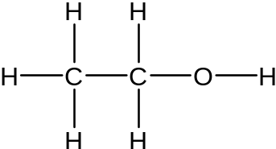
0 | Question answered incorrectly or not attempted.

- Draw structure of oxidation product (ethanoic acid)

Mark | Description
1 | 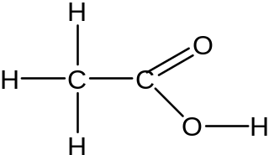
0 | Question answered incorrectly or not attempted.

- Label electron flow on diagram

A
Cathode
Anode
Breath from driver
Bubbles of exhaled air containing ethanol
Dissolved Oxygen

Porous material
electron flow

Mark | Description
1 | Electron flow from anode to cathode through circuit
0 | Question answered incorrectly or not attempted.

- Write half-equation for anode reaction

Mark | Description
2 | CH₃CH₂OH + H₂O → CH₃COOH + 4H⁺ + 4e⁻
1 | One error such as incorrectly balanced.
0 | Question answered incorrectly or not attempted.

- Write half-equation for cathode reaction

Mark | Description
2 | 4H⁺ + O₂ + 4e⁻ → 2H₂O
1 | One error such as incorrectly balanced.
0 | Question answered incorrectly or not attempted

- Write full equation

Mark | Description
1 | CH₃CH₂OH + O₂ → CH₃COOH + H₂O  (or alternative that is correctly based on student’s responses from e) and f) – follow through marks).
0 | Question answered incorrectly or not attempted.

- i) Write an equation for the reaction between ethanol and acidified potassium dichromate.

Mark | Description
2 | 2Cr₂O₇²⁻ + 16H⁺ + 3CH₃CH₂OH → 4Cr³⁺ + 3CH₃COOH + 11H₂O or  Cr₂O₇²⁻ + 8H⁺ + 3CH₃CH₂OH → 2Cr³⁺ + 3CH₃CHO + 7H₂O
1 | One balancing error OR  Student uses permanganate instead of dichromate but correctly balances equation.
0 | Question answered incorrectly or not attempted.

(ii) Compare advantages and disadvantages of methods.

Mark | Description
3 | Fuel cell breathalyser provides a quantitative reading of alcohol in breath, but may react with other things in breath.  Dichromate method gives a fairly qualitative reading but is very portable and inexpensive method. (Or anything reasonable)
2 | Only one method’s advantages and disadvantages described or provided.  Comparison limited.
1 | No comparison attempted but an answer with some value.
0 | Question answered incorrectly or not attempted.

- Could the process described in (g) be used to detect tertiary alcohols? Give a reason for your answer.

Mark | Description
2 | no  tertiary alcohols cannot be oxidised by acidified oxidising agents.
1 | no – but no reason given
0 | Question answered incorrectly or not attempted

Question 10 [15 marks]

- Acetic acid in the form of vinegar is suitable for human consumption. Suggest reasons why 0.1 mol L⁻¹ acetic acid found vinegar can be consumed, but other acids such as 0.1 mol L⁻¹ hydrochloric and 0.05 mol L⁻¹ sulfuric acids should not be consumed.

Mark | Description
3 | Vinegar is a dilute form of a weak acid and only partially ionises while HCl and H₂SO₄ are strong acids and are completely ionised  [H⁺] is lowest in vinegar.
2 | Acetic acid is a weak acid while HCl and H₂SO₄ strong
1 | Acetic acid is a weak acid while HCl and H₂SO₄ are strong
0 | Question answered incorrectly or not at all.

- The most common deposit left in kettles is calcium carbonate. Write an equation to illustrate how acetic acid removes the calcium carbonate.

Mark | Description
2 | CaCO₃ + 2CH₃COOH → Ca²⁺ + 2CH₃COO⁻ + CO₂ + H₂O
1 | CaCO₃ + 2CH₃COOH → Ca(CH₃COO)2 + CO₂ + H₂O
1 | One error (e.g. not balanced correctly)
0 | Question answered incorrectly or not at all.

- Using your understanding of rates and equilibrium, discuss both steps in the commercial production of acetic acid.

Mark | Description
9 – 10 | An increased rate for this set of reactions would be favoured by:  - increase in temperature, as particles move faster and collide more often and more particles have sufficient energy to react. (A graph showing the activation energy the kinetic energy distributions at two different temperatures could be included as a part of the answer.)  - increase in partial pressure or concentration of gases would also increase rate as more particles mean greater chance of collision and therefore faster reaction rate.  - using a catalyst will increase rate as it provides an alternative pathway with a lower activation energy. The catalyst increases the rate of both the forward and reverse reaction. (A diagram of an uncatalysed and catalysed reaction pathway could be included to illustrate the answer.)  An increased yield would be favoured when the reaction is:  - run at a low temperature as the reactions are exothermic. Exothermic reactions have a higher yield at lower temperatures  - run at a high pressure as a high pressure favours the side with fewer number of gaseous particles  The actual reaction conditions require a compromise on the temperature at which the process is carried out at. A low operating temperature would give a higher yield at a slower rate making the process uneconomic.  Note:Answer may include the following reactions, but attainment of full marks is not dependent on their inclusion.  The reactions which do not have to be included in the answer are:  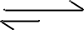  CO_{(g)} + 2 H_{2(g)} CH₃OH_{(g)} Step 1  CH₃OH_{(g)} + CO_{(g)} CH₃COOH_{(g)} Step 2
8 | Answer covers most points as given above but some linking of concepts missing. i.e. The process is discussed only in terms of rate
6 – 7 | Student covers all essential points of rate and yield but does not specifically relate to given process or no equations or diagrams supplied.
4 – 5 | Some points covered and explained.
2 – 3 | Effect on rate and yield of conditions listed but either not explained or not correctly explained.
1 | At least one viable point made.
0 | Question answered incorrectly or not at all.

Question 11 [8 marks]
From this information and your understanding of bonding and structure, identify the
materials you would use. Explain your choices in detail.

Mark | Description
7 – 8 | Answer includes materials chosen, the properties that were used to make the choice and the structure of the materials that explains the properties. For full marks there should be reference to the table of information and the answer should be constructed in a clear and coherent manner. Students may also indicate why materials were inappropriate, but this is not required for full marks.
5 – 6 | Answer includes materials chosen and some linking between properties and structure. The structure explanations should be accurate.
3 – 4 | Answer includes materials chosen and some linking between properties and structure. The structure explanations should have some accuracies and some deficiencies.
1 – 2 | Answer includes materials chosen and one or two properties with no appropriate linking to structure or incorrect structure descriptions and explanation.
0 | Question answered incorrectly or not at all

Question 12 [8 marks]

- A chemist needs to adjust the pH of a 25 000 L batch of waste water discharge that had a pH of 11.3, before releasing it into a stream. He estimated that he could do this by the addition of 420 L of 0.119 mol L⁻¹ HC solution. Determine the pH of the batch of waste water that was discharged into the stream
Equilibrium constant for water at 25ºC K_{w} = 1 x 10⁻¹⁴

Mark | Description
6 | Calculates  - [H⁺] from pH  - [OH⁻] using K_{w}  - moles of OH⁻ in waste water  - moles of excess H⁺  - [H⁺] correctly adding volumes of solutions  - pH.
1 - 5 | 1 mark per point, with follow through marking past the point of error.

[H⁺] = inverse log – 11.3
= 5.012 x 10 ^{– 12}

[OH⁻ ] = 1 x 10 ⁻¹⁴
5.012 x 10 ^{– 12}

= 1.995 x 10⁻³

moles of OH⁻ = 25 000 x 1.995 x 10⁻³

= 4.988 x 10¹

moles of H⁺ = 420 x .0119
added

= 4.998 x 10¹

moles of = 9.844 x 10 ⁻²
excess H⁺

[H⁺] = 9.844 x 10 ⁻²
(25000 + 420)

= 3.872 x 10⁻⁶

pH = - log (3.872x 10⁻⁶)

= 5.41

- Consider the information in the table. Is the pH of the treated waste water appropriate for release into a stream? Justify your answer.
(If you could not obtain a pH value in (a) above use a pH of 5.0.)

Mark | Description
2 | A statement and a supporting argument such as:  - The pH of the waste water is too low to be discharged into the water from an environmental viewpoint.  - The number of moles of excess acid is only small (0.099 moles) and given the volume of water and the resulting dilution in the river this would have minimal environmental impact.  - If the water was discharged into the alkaline river water it would be neutralised.
1 | - The pH of the waste water is too low to be discharged into the water from an environmental viewpoint.
0 | Question answered incorrectly or not at all.

Question 13 [9 marks]
Water is often called the ‘universal solvent’. The solubility of a number of substances is given in the table below.

Substance | Solubilities in water
Sodium bromide (NaBr) | Soluble
Methanol (CH₃OH) | Miscible
Bromine (Br₂) | Slightly soluble

Explain these solubilities in terms of the forces between:
(i) solvent molecules
(ii) particles in the solute
(iii) the solvated particles and the solvent

In your answer you should include equations and diagrams.

Mark | Description
9  (1 mark per point) | Solvent molecule is H₂O, this molecule has permanent dipoles.  - H-bonding bonding occurs between molecules  - diagram showing physical bond between the dipoles on adjacent water molecules  NaBr  - particles in solute are held together due to electrostatic attraction i.e. ionic bonds  - the NaBr is able to dissolve because it is able to form ion – dipole attraction between ions and water molecules  CH₃OH  - H-bonding bonding occurs between methanol molecules  - methanol molecules able to form H-bonds with water molecules  - diagram showing physical bond between the dipoles on methanol and water molecules  Br₂  - bromine is a diatomic molecule and the intermolecular forces between adjacent molecules are dispersion forces  - bromine low solubility is due to the fact that very few bromine molecules have sufficient energy to overcome the strong intermolecular forces between the water molecules

Question 14 [10 marks]

- With reference to the table provided discuss the nature and relative strengths of the intermolecular forces in alcohols. You can use diagrams in your answer.

Mark | Description
6  (1 mark per point) | - all have H-bonds – diagram or explanation of H-bond  - all have dispersion forces – temporary dipoles, diagram or explanation  - H-bonds cause a higher boiling point than corresponding hydrocarbons – comparison methane/methanol or butane/butanol  - dispersion forces increase with number of electrons – not molecular mass or chain length (correctly identify cause  - H-bonding is stronger than dispersion force – compare boiling point of an alcohol to corresponding hydrocarbon  - dispersion forces have a greater influence than H-bonding – increase of boiling point from methane to butane compared with methanol to butanol
3 | Maximum of 3 if the answer only involves H-bonding
0 | Question answered incorrectly or not at all.

- Use your understanding of intermolecular forces to explain the differences between the boiling points of the following pairs of alcohols.

(i) methanol and 1-propanol

Mark | Description
2 | - correctly identifies the intermolecular force responsible as dispersion forces  - both have H-bonding, propanol has more atoms in the chain and hence more electrons producing stronger dispersion forces.
1 | - identifies dispersion forces as cause, without explanation
0 | Question answered incorrectly or not at all.
(ii) 1-butanol and 2-butanol
Mark | Description
2 | - both alcohols have the same number of atoms - the difference is not due to dispersion forces.  - the difference is due to the difference in the shape of the molecule due to the position of the alcohol  - the position of the alcohol reduces the area of contact between adjacent molecules
1 | - identifies the position of the alcohol as the cause, without explanation
0 | Question answered incorrectly or not at all.

Question 15 [14 marks]
A damp mixture of potassium iodide and potassium sulfate was dissolved in water and made up to 250.00 mL. 25.00 mL of this solution was treated with excess barium nitrate until no further precipitate formed. The solid was filtered and washed. It was then dried to a constant weight of 0.218 g.

A second 25.00 mL sample of the solution was treated with excess of lead nitrate solution until no further precipitate formed. The solid mixture of precipitates was filtered and washed. It was then dried to a constant weight of 0.607 g.

- Write the precipitation reaction that occurred in step one

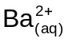 + 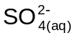 → 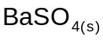

Mark | Description
2 | Writes the correct ionic equation.
1 | Writes a molecular equation.
0 | Question incorrectly answered or not attempted.

- Write the TWO precipitation reactions that occurred in step two.

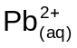 + 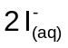 → 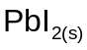

+ 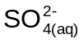 → 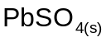

Mark | Description
4 | Identifies correct products.  Writes the correct ionic equation.
3 – 2 | Writes two molecular equations.  Writes one correct ionic equation.
1 | Writes a molecular equation.  Writes one correct ionic equation.
0 | Question incorrectly answered or not attempted.

- Calculate the masses of potassium iodide and potassium sulfate in the original sample.

Mark | Description
8 | m(K₂SO₄) = 1.63 g and m(KI) = 4.37 g
7 | Allow for one mathematical error.
 | Marks assigned as per guide below.
0 | Question incorrectly answered or not attempted.

In the first precipitation reaction

Ba²⁺ + SO₄²⁻ → BaSO₄
n(BaSO₄) = 0.218
233.39
1 mark
= 9.34 x 10⁻⁴ mol

= n(Ba²⁺ ) in 25 mL
1 mark
n(BaSO₄) in = 9.34 x 10⁻⁴ x 10
250mL

= n(K₂SO₄)

m(K₂SO₄) = 9.34 x 10⁻³ x 174.3

= 1.63 g
1 mark

In the second set of precipitation reactions
(i) + →
1 mark
Moles of in 25 mL = moles of SO₄²⁻ in 25 mL in the first solution

= 9.34 x 10⁻⁴ moles

Mass of = 9.34 x 10⁻⁴ x 303.26
1 mark
= 0.283g

Mass of = (0.607 – 0.283) g
1 mark
= 0.324g

Moles of = 0.324
461

= 7.02 x 10⁻⁴

Moles of I⁻ = 2 x 7.02 x 10⁻⁴
1 mark
= 1.404 x 10⁻⁴ in 25 mL

Moles of I⁻ in 250 mL = 1.404 x 10⁻³

Mass of KI in damp mixture = 1.404 x 10⁻³ x 166
1 mark
= 2.33g
ACKNOWLEDGEMENTS

SECTION TWO

Question 6 http://www.ocr.org.uk/Data/publications/specimen_assessment_materials/cquartetOCRTempFileY3R8iY3TBH.pdf

Question 9
EdWest. (2002). Year 12 Chemistry examination. Wembley, WA: Author.
Published by the Curriculum Council of Western Australia
27 Walters Drive
OSBORNE PARK WA 6017

CHEMISTRY
Sample external written examination
Stage 3
Mapping questions to content

Course  content | Macroscopic properties of matter | Atomic structure and bonding | Chemical reactions | Acids and bases in aqueous solutions | Oxidation and reduction | Organic Chemistry | Applied chemistry
Section 1 – Multiple choice
Question
1 |  | ✓
2 |  | ✓
3 |  | ✓
4 | ✓ | ✓
5 | ✓ | ✓
6 |  | ✓ |  | ✓
7 |  |  |  |  | ✓
8 |  |  |  |  | ✓
9 |  |  |  |  | ✓
10 |  |  |  | ✓
11 |  |  |  | ✓
12 |  |  |  | ✓
13 |  |  |  | ✓
14 |  |  |  | ✓
15 |  |  |  | ✓
16 |  |  |  | ✓
17 |  |  |  |  | ✓ |  | ✓
18 |  |  |  |  |  | ✓
19 |  |  |  |  |  | ✓
20 |  |  |  |  |  | ✓
21 |  |  |  |  |  | ✓
22 |  |  | ✓
23 |  |  | ✓
24 |  |  | ✓
25 |  |  | ✓
Section 2
1 |  |  |  |  |  | ✓
2 |  |  |  |  |  | ✓
3 |  |  |  |  |  | ✓
4 |  |  | ✓
5 |  |  |  | ✓ |  |  | ✓
6 |  |  | ✓ |  |  |  | ✓
7 |  |  | ✓ |  |  | ✓
8 |  |  |  | ✓
9 |  |  |  |  | ✓ | ✓ | ✓
10 |  |  | ✓ | ✓
11 |  | ✓ |  |  |  |  | ✓
12 |  |  | ✓ | ✓ |  |  | ✓
13 | ✓ | ✓
14 |  | ✓
15 |  |  | ✓

